Laporan Project Akhir Grafika Komputer

Laporan ini dibuat untuk menyelesaikan tugas mata kuliah Grafika Komputer  
yang dibina oleh : **Muhammad Ilham Perdana, S.Tr.T., M.T**

Disusun Oleh:

Achmad Ardi Sukmadi 202310370311049



**UNIVERSITAS MUHAMMADIYAH MALANG**

**FAKULTAS TEKNIK**

**PROGRAM STUDI INFORMATIA**

**2025**

**Daftar isi**

1. Soal 3

1.1 Modul A Objek 2D 3

1.1.1 Fungsi Penggambaran Objek 3

1.1.2 Fungsi Warna dan ketebalan 3

1.1.3 Tranformasi Geometri 3

1.1.4 Windowing dan Clipping 3

1.2 Modul B: Objek 3D 4

1.2.1 Visualisasi Objek 3D 4

1.2.2 Transformasi Objek 3D 4

1.2.3 Shading dan Pencahayaan 4

1.2.4 Kamera dan Perspektif 4

2. Code 5

2.1 Code Modul A 2D 5

2.2 Code Modul B 3D 12

3. Output 24

3.1 Output Modul A 2D 24

3.1.1 Output Terminal 24

3.1.2 Output Visual 25

3.2 Output Modul A 3D 29

3.2.1 Output Terminal 29

3.2.2 Output Visual 29

4. Deskripsi Penjelasan Masing-Masing Output 34

4.1 Output Modul A 2D 34

4.2 Output Modul B 3D 35

5. Referensi/Sumber Pengerjaan Project 37

# Soal

## Modul A Objek 2D

### Fungsi Penggambaran Objek

1. Gambar Objek Dasar:
2. Titik
3. Garis
4. Persegi
5. Ellipse
6. Koordinat input dilakukan dengan klik mouse pada canvas Opengl

### Fungsi Warna dan ketebalan

1. Pengguna dapat memilih:
2. Warna objek (melalui tombola tau shortcut keyboard)
3. Ketebalan garis (jika menggunakan GL_LINES atau GL_LINE_LOOP).

### Tranformasi Geometri

1. Objek yang telah digambar dapat dikenai transformasi:
2. Translasi
3. Rotasi
4. Scaling
5. Transformasi dilakukan melalui keyboard, tombol menu, atau shortcut.

### Windowing dan Clipping

1. Pengguna dapat menentukan window aktif (misalnya dengan klik 2 titik sudut sebagai batas window).
2. Objek yang:
3. Masuk ke window: akan berubah warna (misalnya menjadi hijau).
4. Di luar window: akan dikenai clipping , hanya bagian dalam window yang ditampilkan (gunakan algoritma Coben-Sutherland atau Liang-Barsky untuk garis).
5. Window dapat digeser atau diuabah ukurannya.

## Modul B: Objek 3D

### Visualisasi Objek 3D

Tampilkan Minimal **1 objek 3D** berbentuk:

1. Kubus atau Piramida dan bisa yang lain juga
2. Dibaca dari file .obj atau Digambar manual (vertex, face)

### Transformasi Objek 3D

Translasi, Rotasi (dengan keyboard atau mouse drag)

### Shading dan Pencahayaan

1. Implementasi model pencahayaan sederhana (phong /gouraud) Menggunakan :

* Ambient Light
* Diffuse Light
* Specular Light

### Kamera dan Perspektif

1. Mengatur posisi kamera (gluLookAt)
2. Menggunakan proyeksi perspektif (gluPerspective) untuk 3D

# Code

## Code Modul A 2D

# Import library yang diperlukan  
import sys  
import os  
from math import sin, cos, radians  
  
try:  
 from OpenGL.GL import *  
 from OpenGL.GLUT import *  
 from OpenGL.GLU import *  
except ImportError:  
 print("Error: PyOpenGL tidak terinstal.")  
 print("Silakan instal dengan perintah: pip install PyOpenGL PyOpenGL_accelerate")  
 sys.exit(1)  
  
# =============================================================================  
# 1. PENGELOLAAN STATE DAN VARIABEL GLOBAL  
# =============================================================================  
  
# Dimensi window  
window_width = 1280  
window_height = 720  
  
# Variabel untuk transformasi objek  
rotation_x = 0.0  
rotation_y = 0.0  
translate_x = 0.0  
translate_y = 0.0  
translate_z = 0.0 # Direset setiap load model  
scale_factor = 1.0  
object_color = [0.6, 0.7, 1.0]  
  
# Variabel untuk interaksi mouse  
mouse_down = False  
last_mouse_x = 0  
last_mouse_y = 0  
  
# Struktur data untuk menyimpan model 3D yang dimuat  
model = {  
 "vertices": [],  
 "normals": [],  
 "faces": [],  
 "center": (0.0, 0.0, 0.0) # Pusat geometris model  
}  
  
  
# =============================================================================  
# 2. FUNGSI IMPORT, EXPORT, DAN MANIPULASI MODEL  
# =============================================================================  
  
def center_model_and_reset_transform():  
 *"""Menghitung pusat model, memindahkannya ke origin, dan mereset transformasi."""* global model, rotation_x, rotation_y, translate_x, translate_y, translate_z, scale_factor  
 if not model["vertices"]:  
 return  
  
 # Hitung bounding box  
 min_x = min(v[0] for v in model["vertices"])  
 max_x = max(v[0] for v in model["vertices"])  
 min_y = min(v[1] for v in model["vertices"])  
 max_y = max(v[1] for v in model["vertices"])  
 min_z = min(v[2] for v in model["vertices"])  
 max_z = max(v[2] for v in model["vertices"])  
  
 # Hitung pusat geometris  
 center_x = (min_x + max_x) / 2.0  
 center_y = (min_y + max_y) / 2.0  
 center_z = (min_z + max_z) / 2.0  
 model["center"] = (center_x, center_y, center_z)  
  
 # Pindahkan semua vertex sehingga pusatnya ada di (0,0,0)  
 new_vertices = []  
 for v in model["vertices"]:  
 new_vertices.append((v[0] - center_x, v[1] - center_y, v[2] - center_z))  
 model["vertices"] = new_vertices  
  
 # Hitung jarak terjauh dari origin untuk menentukan posisi kamera awal  
 max_dist = max(max(abs(v[i]) for v in model["vertices"]) for i in range(3)) if model["vertices"] else 1  
  
 # Reset transformasi  
 rotation_x, rotation_y = 0.0, 0.0  
 translate_x, translate_y = 0.0, 0.0  
 # Atur translate_z agar objek terlihat sepenuhnya  
 translate_z = -max_dist * 2.5  
 scale_factor = 1.0  
 print(f"Model dipusatkan di {model['center']}. Transformasi direset.")  
  
  
def load_obj(filename):  
 *"""Memuat model 3D dari sebuah file .obj."""* global model  
 if not os.path.exists(filename):  
 print(f"Error: File '{filename}' tidak ditemukan.")  
 return  
  
 temp_vertices, temp_normals, temp_faces = [], [], []  
 with open(filename, 'r') as f:  
 for line in f:  
 parts = line.strip().split()  
 if not parts: continue  
  
 if parts[0] == 'v':  
 temp_vertices.append(tuple(map(float, parts[1:4])))  
 elif parts[0] == 'vn':  
 temp_normals.append(tuple(map(float, parts[1:4])))  
 elif parts[0] == 'f':  
 face = []  
 for part in parts[1:]:  
 indices = part.split('/')  
 v_idx = int(indices[0]) - 1  
 vn_idx = int(indices[2]) - 1 if len(indices) > 2 and indices[2] else -1  
 face.append((v_idx, vn_idx))  
 temp_faces.append(tuple(face))  
  
 model = {"vertices": temp_vertices, "normals": temp_normals, "faces": temp_faces}  
 center_model_and_reset_transform() # Pusatkan model setelah dimuat  
 print(f"Model '{filename}' berhasil dimuat: {len(model['vertices'])} vertices, {len(model['faces'])} faces.")  
 glutPostRedisplay()  
  
  
def export_obj(filename):  
 *"""Mengekspor model saat ini (dengan transformasi) ke file .obj."""* if not model["vertices"]:  
 print("Tidak ada model untuk diekspor.")  
 return  
  
 with open(filename, 'w') as f:  
 f.write("# Diekspor oleh Aplikasi Grafika 3D \n")  
 f.write(f"# Vertices: {len(model['vertices'])}\n")  
 f.write(f"# Normals: {len(model['normals'])}\n")  
 f.write(f"# Faces: {len(model['faces'])}\n\n")  
  
 # Tulis semua vertex asli (sebelum transformasi)  
 for v in model["vertices"]:  
 # Tambahkan kembali offset pusat sebelum menulis  
 orig_v = (v[0] + model['center'][0], v[1] + model['center'][1], v[2] + model['center'][2])  
 f.write(f"v {orig_v[0]:.6f} {orig_v[1]:.6f} {orig_v[2]:.6f}\n")  
 f.write("\n")  
  
 # Tulis semua normal asli  
 for n in model["normals"]:  
 f.write(f"vn {n[0]:.6f} {n[1]:.6f} {n[2]:.6f}\n")  
 f.write("\n")  
  
 # Tulis semua face dengan format v//vn  
 for face in model["faces"]:  
 face_str = "f " + " ".join([f"{v_idx + 1}//{vn_idx + 1}" for v_idx, vn_idx in face])  
 f.write(face_str + "\n")  
  
 print(f"Model berhasil diekspor ke '{filename}' dengan data normal.")  
  
  
def load_default_cube():  
 *"""Memuat data kubus default ke dalam struktur model."""* global model  
 model = {  
 "vertices": [  
 (1, -1, -1), (1, 1, -1), (-1, 1, -1), (-1, -1, -1),  
 (1, -1, 1), (1, 1, 1), (-1, -1, 1), (-1, 1, 1)  
 ],  
 "normals": [  
 (0, 0, -1), (0, 0, 1), (1, 0, 0), (-1, 0, 0), (0, 1, 0), (0, -1, 0)  
 ],  
 "faces": [  
 ((0, 0), (1, 0), (2, 0), (3, 0)), # Belakang  
 ((4, 1), (5, 1), (7, 1), (6, 1)), # Depan  
 ((0, 2), (4, 2), (6, 2), (3, 2)), # Kanan  
 ((1, 3), (5, 3), (7, 3), (2, 3)), # Kiri  
 ((1, 4), (5, 4), (4, 4), (0, 4)), # Atas  
 ((3, 5), (2, 5), (7, 5), (6, 5)) # Bawah  
 ]  
 }  
 center_model_and_reset_transform() # Pusatkan kubus juga  
  
  
# =============================================================================  
# 3. DOKUMENTASI DAN BANTUAN  
# =============================================================================  
  
def print_instructions():  
 *"""Mencetak panduan penggunaan ke konsol."""* print("=" * 60)  
 print(" Aplikasi Grafika 3D Interaktif - PyOpenGL v1.5")  
 print("=" * 60)  
 print("--- FILE ---")  
 print(" [I] Import File .obj (Ketik nama file di konsol)")  
 print(" [O] Export File .obj (Ketik nama file di konsol)")  
 print("\n--- KONTROL OBJEK ---")  
 print(" Rotasi : Klik kiri dan seret mouse")  
 print(" Zoom : Scroll mouse wheel")  
 print(" Translasi : W, A, S, D")  
 print("\n--- UBAH WARNA ---")  
 print(" [1] Merah | [2] Hijau | [3] Biru | [4] Kuning | [5] Jingga | [6] Default")  
 print("\n--- KONTROL APLIKASI ---")  
 print(" Keluar : Tekan tombol ESC")  
 print("=" * 60)  
  
  
# =============================================================================  
# 4. FUNGSI MENGGAMBAR OBJEK  
# =============================================================================  
  
def draw_model():  
 *"""Menggambar model yang saat ini dimuat dengan shading yang benar."""* if not model["faces"]: return  
  
 for face in model["faces"]:  
 # Gambar sebagai triangles atau quads tergantung jumlah vertex  
 if len(face) == 3:  
 glBegin(GL_TRIANGLES)  
 elif len(face) == 4:  
 glBegin(GL_QUADS)  
 else:  
 glBegin(GL_POLYGON)  
  
 for v_idx, vn_idx in face:  
 # Terapkan normal untuk SETIAP vertex untuk smooth shading  
 if model["normals"] and vn_idx != -1:  
 glNormal3fv(model["normals"][vn_idx])  
 glVertex3fv(model["vertices"][v_idx])  
 glEnd()  
  
  
# =============================================================================  
# 5. FUNGSI CALLBACK UTAMA OPENGL/GLUT  
# =============================================================================  
  
def display():  
 *"""Fungsi display utama, dipanggil setiap kali layar perlu digambar ulang."""* glClear(GL_COLOR_BUFFER_BIT | GL_DEPTH_BUFFER_BIT)  
 glLoadIdentity()  
 gluLookAt(0, 0, 5, 0, 0, 0, 0, 1, 0)  
  
 light_position = [2.0, 3.0, 4.0, 1.0]  
 glLightfv(GL_LIGHT0, GL_POSITION, light_position)  
  
 # Terapkan transformasi interaktif. Rotasi kini terjadi di sekitar (0,0,0)  
 # karena modelnya sudah dipusatkan.  
 glPushMatrix() # Simpan matriks saat ini  
 glTranslatef(translate_x, translate_y, translate_z)  
 glRotatef(rotation_x, 1, 0, 0)  
 glRotatef(rotation_y, 0, 1, 0)  
 glScalef(scale_factor, scale_factor, scale_factor)  
  
 glColor3fv(object_color)  
 draw_model()  
 glPopMatrix() # Kembalikan matriks  
  
 glutSwapBuffers()  
  
  
def reshape(w, h):  
 *"""Callback saat window diubah ukurannya."""* global window_width, window_height  
 window_width, window_height = w, h  
 if h == 0: h = 1  
 glViewport(0, 0, w, h)  
 glMatrixMode(GL_PROJECTION)  
 glLoadIdentity()  
 gluPerspective(45.0, float(w) / float(h), 0.1, 500.0) # Perbesar zFar  
 glMatrixMode(GL_MODELVIEW)  
 glLoadIdentity()  
  
  
def init():  
 *"""Inisialisasi state OpenGL."""* glClearColor(1.0, 1.0, 1.0, 1.0)  
 glEnable(GL_DEPTH_TEST)  
 glEnable(GL_LIGHTING)  
 glEnable(GL_LIGHT0)  
 glShadeModel(GL_SMOOTH)  
  
 # PERBAIKAN: Aktifkan normalisasi otomatis untuk vektor normal.  
 # Ini memastikan pencahayaan tetap akurat bahkan setelah objek di-skala.  
 glEnable(GL_NORMALIZE)  
  
 light_ambient = [0.2, 0.2, 0.2, 1.0]  
 light_diffuse = [1.0, 1.0, 1.0, 1.0]  
 light_specular = [1.0, 1.0, 1.0, 1.0]  
 glLightfv(GL_LIGHT0, GL_AMBIENT, light_ambient)  
 glLightfv(GL_LIGHT0, GL_DIFFUSE, light_diffuse)  
 glLightfv(GL_LIGHT0, GL_SPECULAR, light_specular)  
  
 mat_ambient = [0.7, 0.7, 0.7, 1.0]  
 mat_diffuse = [0.8, 0.8, 0.8, 1.0]  
 mat_specular = [1.0, 1.0, 1.0, 1.0]  
 mat_shininess = [100.0]  
 glMaterialfv(GL_FRONT, GL_AMBIENT, mat_ambient)  
 glMaterialfv(GL_FRONT, GL_DIFFUSE, mat_diffuse)  
 glMaterialfv(GL_FRONT, GL_SPECULAR, mat_specular)  
 glMaterialfv(GL_FRONT, GL_SHININESS, mat_shininess)  
  
 glEnable(GL_COLOR_MATERIAL)  
 glColorMaterial(GL_FRONT, GL_DIFFUSE)  
  
 load_default_cube()  
 print_instructions()  
  
  
# =============================================================================  
# 6. FUNGSI CALLBACK INPUT (MOUSE DAN KEYBOARD)  
# =============================================================================  
  
def keyboard(key, x, y):  
 *"""Callback untuk input keyboard."""* global translate_x, translate_y, scale_factor, object_color  
  
 try:  
 key_char = key.decode("utf-8").lower()  
 except UnicodeDecodeError:  
 return  
  
 step = 0.2  
 scale_step = 1.1  
  
 if key == b'\x1b':  
 print("Keluar dari aplikasi.")  
 glutLeaveMainLoop()  
 elif key_char == 'i':  
 filename = input(">>> Masukkan nama file .obj untuk diimpor: ")  
 load_obj(filename)  
 elif key_char == 'o':  
 filename = input(">>> Masukkan nama file .obj untuk diekspor: ")  
 export_obj(filename)  
 elif key_char == 'w':  
 translate_y += step  
 elif key_char == 's':  
 translate_y -= step  
 elif key_char == 'a':  
 translate_x -= step  
 elif key_char == 'd':  
 translate_x += step  
 elif key_char in ['=', '+']:  
 scale_factor *= scale_step  
 elif key_char == '-':  
 scale_factor /= scale_step  
 elif key_char == '1':  
 object_color = [1.0, 0.3, 0.3]; print("Warna: Merah")  
 elif key_char == '2':  
 object_color = [0.3, 1.0, 0.3]; print("Warna: Hijau")  
 elif key_char == '3':  
 object_color = [0.3, 0.3, 1.0]; print("Warna: Biru")  
 elif key_char == '4':  
 object_color = [1.0, 1.0, 0.3]; print("Warna: Kuning")  
 elif key_char == '5':  
 object_color = [1.0, 0.3, 1.0]; print("Warna: Jingga")  
 elif key_char == '6':  
 object_color = [0.6, 0.7, 1.0]; print("Warna: Biru Muda (Default)")  
 glutPostRedisplay()  
  
  
def mouse_click(button, state, x, y):  
 *"""Callback untuk klik mouse (rotasi)."""* global mouse_down, last_mouse_x, last_mouse_y  
 if button == GLUT_LEFT_BUTTON:  
 if state == GLUT_DOWN:  
 mouse_down = True  
 last_mouse_x, last_mouse_y = x, y  
 elif state == GLUT_UP:  
 mouse_down = False  
  
  
def mouse_motion(x, y):  
 *"""Callback untuk gerakan mouse (rotasi)."""* global rotation_x, rotation_y, last_mouse_x, last_mouse_y  
 if mouse_down:  
 dx, dy = x - last_mouse_x, y - last_mouse_y  
 rotation_y += dx * 0.5  
 rotation_x += dy * 0.5  
 last_mouse_x, last_mouse_y = x, y  
 glutPostRedisplay()  
  
  
def mouse_wheel(wheel, direction, x, y):  
 *"""Callback untuk scroll mouse (zoom/skala)."""* global scale_factor  
 scale_step = 1.1  
 if direction > 0:  
 scale_factor *= scale_step  
 elif direction < 0:  
 scale_factor /= scale_step  
 glutPostRedisplay()  
  
  
# =============================================================================  
# 7. FUNGSI MAIN  
# =============================================================================  
  
def main():  
 *"""Fungsi utama untuk menginisialisasi GLUT dan memulai loop."""* glutInit(sys.argv)  
 glutInitDisplayMode(GLUT_RGBA | GLUT_DOUBLE | GLUT_DEPTH)  
 glutInitWindowSize(window_width, window_height)  
 glutInitWindowPosition(100, 100)  
 glutCreateWindow(b"Aplikasi Grafika 3D Interaktif - OpenGL")  
  
 glutDisplayFunc(display)  
 glutReshapeFunc(reshape)  
 glutKeyboardFunc(keyboard)  
 glutMouseFunc(mouse_click)  
 glutMotionFunc(mouse_motion)  
 glutMouseWheelFunc(mouse_wheel)  
  
 init()  
 glutMainLoop()  
  
  
if __name__ == "__main__":  
 main()

## Code Modul B 3D

# Import library yang diperlukan  
import sys  
import copy  
from math import sin, cos, pi, sqrt, radians, degrees  
  
try:  
 from OpenGL.GL import *  
 from OpenGL.GLUT import *  
 from OpenGL.GLU import *  
except ImportError:  
 print("Error: PyOpenGL tidak terinstal.")  
 print("Silakan instal dengan perintah: pip install PyOpenGL PyOpenGL_accelerate")  
 sys.exit(1)  
  
# =============================================================================  
# 1. PENGELOLAAN STATE DAN VARIABEL GLOBAL  
# =============================================================================  
  
# Dimensi window  
window_width = 1280  
window_height = 720  
  
# List untuk menyimpan semua objek yang digambar  
objects = []  
selected_indices = []  
clipboard = []  
  
# State aplikasi  
current_mode = 'select'  
is_drawing = False  
is_dragging_selection = False  
drag_last_pos = {'x': 0, 'y': 0}  
  
# Atribut objek baru  
current_color = (0.0, 0.0, 0.0)  
current_thickness = 1.0  
  
# Variabel sementara  
temp_vertex = None  
ghost_object = None  
selection_box = None  
  
# Definisi clipping window  
clipping_window = {  
 'xmin': 100, 'ymin': 100, 'xmax': 500, 'ymax': 400,  
 'active': False,  
 'color': (1.0, 0.0, 0.0),  
}  
  
# Konstanta Cohen-Sutherland  
C_INSIDE, C_LEFT, C_RIGHT, C_BOTTOM, C_TOP = 0, 1, 2, 4, 8  
  
  
# =============================================================================  
# 2. DOKUMENTASI DAN BANTUAN  
# =============================================================================  
  
def print_instructions():  
 *"""Mencetak panduan penggunaan ke konsol."""* print("=" * 60)  
 print(" Aplikasi Grafika 2D Interaktif - PyOpenGL v1.7.1")  
 print("=" * 60)  
 print("--- MODE ---")  
 print(" [P] Titik | [L] Garis | [R] Persegi | [E] Elips")  
 print(" [ESC] Kembali ke Mode Seleksi (Select)")  
 print("\n--- SELEKSI & TRANSFORMASI ---")  
 print(" Klik pada objek untuk memilih.")  
 print(" Klik & Seret di area kosong untuk memilih beberapa objek.")  
 print(" Klik & Tahan pada objek terpilih untuk menggesernya.")  
 print(" [Shift+Klik] atau [Shift+Seret] untuk menambah/mengurangi objek.")  
 print(" [Ctrl+A] untuk memilih semua objek.")  
 print(" Gunakan Panah untuk Translasi, [Q/A] untuk Rotasi, [W/S] untuk Skala.")  
 print("\n--- MANAJEMEN OBJEK ---")  
 print(" [Ctrl+C] : Copy objek terpilih.")  
 print(" [Ctrl+V] : Paste objek dari clipboard.")  
 print(" [DELETE] / [BACKSPACE] : Hapus objek yang dipilih.")  
 print(" [Shift+DELETE] : Hapus SEMUA objek (Clear All).")  
 print("\n--- WARNA & KETEBALAN ---")  
 print(" [1] Hitam | [2] Merah | [3] Hijau | [4] Biru")  
 print(" [+/-] Ubah Ketebalan Garis")  
 print("\n--- WINDOWING & CLIPPING ---")  
 print(" [C] Buat Window (Klik & Seret) | [D] Nonaktifkan Window")  
 print(" [G] Masuk mode Geser/Resize Window (Gunakan Panah / Shift+Panah)")  
 print("=" * 60)  
  
  
# =============================================================================  
# 3. FUNGSI HELPER, MATEMATIKA, DAN ALGORITMA  
# =============================================================================  
  
def create_object(obj_type, vertices, color, thickness):  
 *"""Membuat dictionary objek baru dan menambahkannya ke list."""* global objects, selected_indices  
 new_obj = {  
 'type': obj_type,  
 'vertices': vertices,  
 'color': color,  
 'thickness': thickness,  
 'transform': {'translate': [0, 0], 'rotate': 0.0, 'scale': [1.0, 1.0]}  
 }  
 objects.append(new_obj)  
 selected_indices = [len(objects) - 1]  
  
  
def copy_selected_objects():  
 *"""Menyalin objek terpilih ke clipboard."""* global clipboard  
 if not selected_indices:  
 print("Tidak ada objek yang dipilih untuk di-copy.")  
 return  
 clipboard.clear()  
 for index in selected_indices:  
 clipboard.append(copy.deepcopy(objects[index]))  
 print(f"{len(clipboard)} objek di-copy ke clipboard.")  
  
  
def paste_objects():  
 *"""Menempelkan objek dari clipboard."""* global objects, selected_indices  
 if not clipboard:  
 print("Clipboard kosong.")  
 return  
 new_indices = []  
 for obj_to_paste in clipboard:  
 new_obj = copy.deepcopy(obj_to_paste)  
 new_obj['transform']['translate'][0] += 15  
 new_obj['transform']['translate'][1] += 15  
 objects.append(new_obj)  
 new_indices.append(len(objects) - 1)  
 selected_indices = new_indices  
 print(f"{len(new_indices)} objek di-paste.")  
 glutPostRedisplay()  
  
  
def delete_selected_objects():  
 *"""Menghapus semua objek yang sedang dipilih."""* global objects, selected_indices  
 if not selected_indices: return  
 print(f"Menghapus {len(selected_indices)} objek terpilih...")  
 objects = [obj for i, obj in enumerate(objects) if i not in selected_indices]  
 selected_indices.clear()  
 glutPostRedisplay()  
  
  
def clear_all():  
 *"""Menghapus semua objek dari canvas."""* global objects, selected_indices  
 print("Menghapus semua objek...");  
 objects.clear();  
 selected_indices.clear();  
 glutPostRedisplay()  
  
  
def select_all():  
 *"""Memilih semua objek di canvas."""* global selected_indices  
 selected_indices = list(range(len(objects)))  
 print(f"Memilih semua ({len(selected_indices)}) objek.");  
 glutPostRedisplay()  
  
  
def get_object_center(obj):  
 if not obj['vertices']: return (0, 0)  
 if obj['type'] in ['point', 'ellipse', 'freehand']: return obj['vertices'][0]  
 x_coords = [v[0] for v in obj['vertices']];  
 y_coords = [v[1] for v in obj['vertices']]  
 return (sum(x_coords) / len(x_coords), sum(y_coords) / len(y_coords))  
  
  
def get_transformed_vertex(vertex, obj):  
 center = get_object_center(obj);  
 tr = obj['transform']  
 vx, vy = vertex[0] - center[0], vertex[1] - center[1]  
 vx, vy = vx * tr['scale'][0], vy * tr['scale'][1]  
 angle_rad = radians(tr['rotate']);  
 cos_a, sin_a = cos(angle_rad), sin(angle_rad)  
 rvx = vx * cos_a - vy * sin_a;  
 rvy = vx * sin_a + vy * cos_a  
 final_x = rvx + center[0] + tr['translate'][0];  
 final_y = rvy + center[1] + tr['translate'][1]  
 return (final_x, final_y)  
  
  
def get_object_aabb(obj):  
 if not obj['vertices']: return None  
 if obj['type'] == 'ellipse':  
 center_x, center_y = obj['vertices'][0]  
 rx = abs(obj['vertices'][1][0] - center_x);  
 ry = abs(obj['vertices'][1][1] - center_y)  
 verts_to_check = [(center_x + rx, center_y), (center_x - rx, center_y), (center_x, center_y + ry),  
 (center_x, center_y - ry)]  
 else:  
 verts_to_check = obj['vertices']  
 transformed_verts = [get_transformed_vertex(v, obj) for v in verts_to_check]  
 min_x = min(v[0] for v in transformed_verts);  
 max_x = max(v[0] for v in transformed_verts)  
 min_y = min(v[1] for v in transformed_verts);  
 max_y = max(v[1] for v in transformed_verts)  
 return (min_x, min_y, max_x, max_y)  
  
  
def get_inverse_transformed_point(x, y, obj):  
 center = get_object_center(obj);  
 tr = obj['transform']  
 px, py = x - tr['translate'][0], y - tr['translate'][1]  
 px, py = px - center[0], py - center[1]  
 angle_rad = radians(-tr['rotate']);  
 cos_a, sin_a = cos(angle_rad), sin(angle_rad)  
 rpx = px * cos_a - py * sin_a;  
 rpy = px * sin_a + py * cos_a  
 px, py = rpx, rpy  
 sx = tr['scale'][0] if tr['scale'][0] != 0 else 1.0;  
 sy = tr['scale'][1] if tr['scale'][1] != 0 else 1.0  
 px, py = px / sx, py / sy  
 final_px, final_py = px + center[0], py + center[1]  
 return final_px, final_py  
  
  
def dist_sq(p1, p2):  
 return (p1[0] - p2[0]) ** 2 + (p1[1] - p2[1]) ** 2  
  
  
def is_point_on_object(x, y, obj):  
 ix, iy = get_inverse_transformed_point(x, y, obj)  
 tolerance_sq = (obj['thickness'] * 3 + 3) ** 2  
 obj_type, verts = obj['type'], obj['vertices']  
 if obj_type == 'point':  
 return dist_sq((ix, iy), verts[0]) < tolerance_sq * 2  
 elif obj_type == 'line':  
 p, v, w = (ix, iy), verts[0], verts[1];  
 l2 = dist_sq(v, w)  
 if l2 == 0: return dist_sq(p, v) < tolerance_sq  
 t = max(0, min(1, ((p[0] - v[0]) * (w[0] - v[0]) + (p[1] - v[1]) * (w[1] - v[1])) / l2))  
 proj = (v[0] + t * (w[0] - v[0]), v[1] + t * (w[1] - v[1]))  
 return dist_sq(p, proj) < tolerance_sq  
 elif obj_type == 'rectangle':  
 x_coords = sorted([verts[0][0], verts[1][0]]);  
 y_coords = sorted([verts[0][1], verts[1][1]])  
 return (x_coords[0] <= ix <= x_coords[1] and y_coords[0] <= iy <= y_coords[1])  
 elif obj_type == 'ellipse':  
 center = verts[0];  
 rx, ry = abs(verts[1][0] - center[0]), abs(verts[1][1] - center[1])  
 if rx == 0 or ry == 0: return False  
 val = ((ix - center[0]) ** 2 / rx ** 2) + ((iy - center[1]) ** 2 / ry ** 2)  
 return val <= 1.1  
 elif obj_type == 'freehand':  
 for i in range(len(verts) - 1):  
 if is_point_on_object(x, y,  
 {'type': 'line', 'vertices': [verts[i], verts[i + 1]], 'thickness': obj['thickness'],  
 'transform': obj['transform']}):  
 return True  
 return False  
  
  
def is_object_fully_inside_window(obj):  
 if not obj['vertices']: return False  
 aabb = get_object_aabb(obj)  
 if not aabb: return False  
 return (clipping_window['xmin'] <= aabb[0] and aabb[2] <= clipping_window['xmax'] and  
 clipping_window['ymin'] <= aabb[1] and aabb[3] <= clipping_window['ymax'])  
  
  
def compute_outcode(x, y):  
 code = C_INSIDE  
 if x < clipping_window['xmin']:  
 code |= C_LEFT  
 elif x > clipping_window['xmax']:  
 code |= C_RIGHT  
 if y < clipping_window['ymin']:  
 code |= C_BOTTOM  
 elif y > clipping_window['ymax']:  
 code |= C_TOP  
 return code  
  
  
def cohen_sutherland_clip(x1, y1, x2, y2):  
 outcode1, outcode2 = compute_outcode(x1, y1), compute_outcode(x2, y2)  
 accept = False  
 while True:  
 if not (outcode1 | outcode2):  
 accept = True; break  
 elif (outcode1 & outcode2):  
 break  
 else:  
 x, y = 0, 0  
 outcode_out = outcode1 if outcode1 else outcode2  
 if outcode_out & C_TOP:  
 x = x1 + (x2 - x1) * (clipping_window['ymax'] - y1) / (y2 - y1); y = clipping_window['ymax']  
 elif outcode_out & C_BOTTOM:  
 x = x1 + (x2 - x1) * (clipping_window['ymin'] - y1) / (y2 - y1); y = clipping_window['ymin']  
 elif outcode_out & C_RIGHT:  
 y = y1 + (y2 - y1) * (clipping_window['xmax'] - x1) / (x2 - x1); x = clipping_window['xmax']  
 elif outcode_out & C_LEFT:  
 y = y1 + (y2 - y1) * (clipping_window['xmin'] - x1) / (x2 - x1); x = clipping_window['xmin']  
 if outcode_out == outcode1:  
 x1, y1 = x, y; outcode1 = compute_outcode(x1, y1)  
 else:  
 x2, y2 = x, y; outcode2 = compute_outcode(x2, y2)  
 return (True, x1, y1, x2, y2) if accept else (False, 0, 0, 0, 0)  
  
  
# =============================================================================  
# 4. FUNGSI MENGGAMBAR OBJEK (HANYA VISUAL)  
# =============================================================================  
  
def draw_point(vertices, color, thickness):  
 glPointSize(thickness * 5);  
 glColor3fv(color);  
 glBegin(GL_POINTS);  
 glVertex2fv(vertices[0]);  
 glEnd()  
  
  
def draw_line(vertices, color, thickness, clip=False):  
 x1, y1 = vertices[0];  
 x2, y2 = vertices[1]  
 if clip and clipping_window['active']:  
 visible, nx1, ny1, nx2, ny2 = cohen_sutherland_clip(x1, y1, x2, y2)  
 if not visible: return  
 x1, y1, x2, y2 = nx1, ny1, nx2, ny2  
 glLineWidth(thickness);  
 glColor3fv(color);  
 glBegin(GL_LINES);  
 glVertex2f(x1, y1);  
 glVertex2f(x2, y2);  
 glEnd()  
  
  
def draw_rectangle(vertices, color, thickness, clip=False):  
 x1, y1 = vertices[0];  
 x2, y2 = vertices[1]  
 lines = [((x1, y1), (x2, y1)), ((x2, y1), (x2, y2)), ((x2, y2), (x1, y2)), ((x1, y2), (x1, y1))]  
 for line in lines: draw_line(line, color, thickness, clip)  
  
  
def draw_ellipse(vertices, color, thickness, clip=False):  
 center_x, center_y = vertices[0];  
 rx = abs(vertices[1][0] - center_x);  
 ry = abs(vertices[1][1] - center_y)  
 num_segments = 100  
 glLineWidth(thickness);  
 glColor3fv(color);  
 glBegin(GL_LINE_LOOP)  
 for i in range(num_segments):  
 theta = 2.0 * pi * i / num_segments  
 x = rx * cos(theta) + center_x;  
 y = ry * sin(theta) + center_y  
 if clip and clipping_window['active'] and not (  
 clipping_window['xmin'] <= x <= clipping_window['xmax'] and clipping_window['ymin'] <= y <=  
 clipping_window['ymax']):  
 glEnd();  
 glBegin(GL_LINE_LOOP);  
 continue  
 glVertex2f(x, y)  
 glEnd()  
  
  
def draw_freehand(vertices, color, thickness, clip=False):  
 glLineWidth(thickness);  
 glColor3fv(color);  
 glBegin(GL_LINE_STRIP)  
 for v in vertices:  
 if clip and clipping_window['active'] and not (  
 clipping_window['xmin'] <= v[0] <= clipping_window['xmax'] and clipping_window['ymin'] <= v[1] <=  
 clipping_window['ymax']):  
 glEnd();  
 glBegin(GL_LINE_STRIP);  
 continue  
 glVertex2fv(v)  
 glEnd()  
  
  
def draw_clipping_window():  
 if clipping_window['active']:  
 glEnable(GL_LINE_STIPPLE);  
 glLineStipple(4, 0xAAAA);  
 glColor3fv(clipping_window['color']);  
 glLineWidth(2.0)  
 glBegin(GL_LINE_LOOP)  
 glVertex2f(clipping_window['xmin'], clipping_window['ymin']);  
 glVertex2f(clipping_window['xmax'], clipping_window['ymin'])  
 glVertex2f(clipping_window['xmax'], clipping_window['ymax']);  
 glVertex2f(clipping_window['xmin'], clipping_window['ymax'])  
 glEnd()  
 glDisable(GL_LINE_STIPPLE)  
  
  
def draw_selection_box():  
 if selection_box:  
 x1, y1, x2, y2 = selection_box  
 glColor3f(0.3, 0.5, 0.9);  
 glLineWidth(1.0)  
 glBegin(GL_LINE_LOOP)  
 glVertex2f(x1, y1);  
 glVertex2f(x2, y1);  
 glVertex2f(x2, y2);  
 glVertex2f(x1, y2)  
 glEnd()  
 glEnable(GL_BLEND);  
 glBlendFunc(GL_SRC_ALPHA, GL_ONE_MINUS_SRC_ALPHA)  
 glColor4f(0.3, 0.5, 0.9, 0.2)  
 glBegin(GL_QUADS)  
 glVertex2f(x1, y1);  
 glVertex2f(x2, y1);  
 glVertex2f(x2, y2);  
 glVertex2f(x1, y2)  
 glEnd()  
 glDisable(GL_BLEND)  
  
  
# =============================================================================  
# 5. FUNGSI CALLBACK UTAMA OPENGL/GLUT  
# =============================================================================  
  
def display():  
 glClear(GL_COLOR_BUFFER_BIT | GL_DEPTH_BUFFER_BIT);  
 glLoadIdentity()  
 for i, obj in enumerate(objects):  
 display_color = obj['color']  
 if i in selected_indices: display_color = (0.9, 0.5, 0.0)  
 if clipping_window['active'] and is_object_fully_inside_window(obj): display_color = (0.1, 0.8, 0.2)  
 glPushMatrix()  
 center = get_object_center(obj)  
 glTranslatef(obj['transform']['translate'][0], obj['transform']['translate'][1], 0)  
 glTranslatef(center[0], center[1], 0)  
 glRotatef(obj['transform']['rotate'], 0, 0, 1)  
 glScalef(obj['transform']['scale'][0], obj['transform']['scale'][1], 1)  
 glTranslatef(-center[0], -center[1], 0)  
 obj_type = obj['type']  
 if obj_type == 'point':  
 draw_point(obj['vertices'], display_color, obj['thickness'])  
 elif obj_type == 'line':  
 draw_line(obj['vertices'], display_color, obj['thickness'], clip=True)  
 elif obj_type == 'rectangle':  
 draw_rectangle(obj['vertices'], display_color, obj['thickness'], clip=True)  
 elif obj_type == 'ellipse':  
 draw_ellipse(obj['vertices'], display_color, obj['thickness'], clip=True)  
 elif obj_type == 'freehand':  
 draw_freehand(obj['vertices'], display_color, obj['thickness'], clip=True)  
 glPopMatrix()  
  
 if is_drawing and ghost_object:  
 obj = ghost_object;  
 color = (0.5, 0.5, 0.5)  
 if obj['type'] == 'draw_line':  
 draw_line(obj['vertices'], color, obj['thickness'])  
 elif obj['type'] == 'draw_rectangle':  
 draw_rectangle(obj['vertices'], color, obj['thickness'])  
 elif obj['type'] == 'draw_ellipse':  
 draw_ellipse(obj['vertices'], color, obj['thickness'])  
 elif obj['type'] == 'define_window':  
 draw_rectangle(obj['vertices'], clipping_window['color'], 1.5)  
  
 draw_clipping_window()  
 draw_selection_box()  
 glutSwapBuffers()  
  
  
def reshape(w, h):  
 global window_width, window_height  
 window_width, window_height = w, h  
 glViewport(0, 0, w, h if h > 0 else 1)  
 glMatrixMode(GL_PROJECTION);  
 glLoadIdentity();  
 gluOrtho2D(0.0, w, 0.0, h);  
 glMatrixMode(GL_MODELVIEW);  
 glLoadIdentity()  
  
  
def init():  
 glClearColor(1.0, 1.0, 1.0, 1.0);  
 glEnable(GL_BLEND);  
 glBlendFunc(GL_SRC_ALPHA, GL_ONE_MINUS_SRC_ALPHA)  
 glEnable(GL_LINE_SMOOTH);  
 print_instructions()  
  
  
# =============================================================================  
# 6. FUNGSI CALLBACK INPUT (MOUSE DAN KEYBOARD)  
# =============================================================================  
  
def mouse_click(button, state, x, y):  
 global current_mode, is_drawing, temp_vertex, ghost_object, selected_indices, selection_box  
 global is_dragging_selection, drag_last_pos  
 y = window_height - y  
  
 if button == GLUT_LEFT_BUTTON:  
 if state == GLUT_DOWN:  
 mods = glutGetModifiers()  
 if current_mode == 'select':  
 clicked_on_object = False  
 for i in selected_indices:  
 if is_point_on_object(x, y, objects[i]):  
 is_dragging_selection = True  
 drag_last_pos = {'x': x, 'y': y}  
 clicked_on_object = True  
 break  
 if not is_dragging_selection:  
 for i in range(len(objects) - 1, -1, -1):  
 if is_point_on_object(x, y, objects[i]):  
 if mods == GLUT_ACTIVE_SHIFT:  
 if i in selected_indices:  
 selected_indices.remove(i)  
 else:  
 selected_indices.append(i)  
 else:  
 selected_indices = [i]  
 clicked_on_object = True  
 break  
 if not clicked_on_object:  
 is_drawing = True  
 selection_box = (x, y, x, y)  
 if mods != GLUT_ACTIVE_SHIFT:  
 selected_indices.clear()  
 else:  
 is_drawing = True;  
 temp_vertex = (x, y)  
 if current_mode == 'draw_point':  
 create_object('point', [(x, y)], current_color, current_thickness); is_drawing = False  
 elif current_mode == 'draw_freehand':  
 create_object('freehand', [temp_vertex], current_color, current_thickness)  
 elif current_mode in ['draw_line', 'draw_rectangle', 'draw_ellipse', 'define_window']:  
 ghost_object = {'type': current_mode, 'vertices': [temp_vertex, temp_vertex],  
 'color': current_color, 'thickness': current_thickness}  
 elif state == GLUT_UP:  
 is_dragging_selection = False  
 if selection_box:  
 x1, y1, x2, y2 = selection_box  
 sel_xmin, sel_xmax = min(x1, x2), max(x1, x2)  
 sel_ymin, sel_ymax = min(y1, y2), max(y1, y2)  
 newly_selected = set(selected_indices)  
 for i, obj in enumerate(objects):  
 aabb = get_object_aabb(obj)  
 if aabb and not (  
 sel_xmax < aabb[0] or sel_xmin > aabb[2] or sel_ymax < aabb[1] or sel_ymin > aabb[3]):  
 newly_selected.add(i)  
 selected_indices = list(newly_selected)  
 print(f"{len(selected_indices)} objek terpilih.")  
 if is_drawing and ghost_object:  
 if current_mode in ['draw_line', 'draw_rectangle', 'draw_ellipse']:  
 create_object(ghost_object['type'].replace('draw_', ''), ghost_object['vertices'], current_color,  
 current_thickness)  
 elif current_mode == 'define_window':  
 vx = sorted([ghost_object['vertices'][0][0], ghost_object['vertices'][1][0]])  
 vy = sorted([ghost_object['vertices'][0][1], ghost_object['vertices'][1][1]])  
 clipping_window.update({'xmin': vx[0], 'ymin': vy[0], 'xmax': vx[1], 'ymax': vy[1], 'active': True})  
 print("Clipping window didefinisikan.");  
 current_mode = 'select'  
 is_drawing = False;  
 ghost_object = None;  
 temp_vertex = None;  
 selection_box = None  
 glutPostRedisplay()  
  
  
def mouse_motion(x, y):  
 global selection_box, drag_last_pos  
 y = window_height - y  
 if is_dragging_selection:  
 dx = x - drag_last_pos['x'];  
 dy = y - drag_last_pos['y']  
 for index in selected_indices:  
 objects[index]['transform']['translate'][0] += dx  
 objects[index]['transform']['translate'][1] += dy  
 drag_last_pos = {'x': x, 'y': y}  
 glutPostRedisplay()  
 return  
 if not is_drawing: return  
 if selection_box:  
 x1, y1, _, _ = selection_box  
 = (x1, y1, x, y)  
 elif current_mode == 'draw_freehand':  
 if objects and objects[-1]['type'] == 'freehand': objects[-1]['vertices'].append((x, y))  
 elif ghost_object and temp_vertex:  
 ghost_object['vertices'][1] = (x, y)  
 glutPostRedisplay()  
  
  
def keyboard(key, x, y):  
 global current_mode, current_color, current_thickness  
 mods = glutGetModifiers()  
  
 # --- PERBAIKAN: Cek byte code untuk shortcut Ctrl ---  
 # Kode ini mendeteksi karakter kontrol ASCII yang dikirim saat Ctrl+key ditekan.  
 if key == b'\x01': # Ctrl+A  
 select_all();  
 return  
 if key == b'\x03': # Ctrl+C  
 copy_selected_objects();  
 return  
 if key == b'\x16': # Ctrl+V  
 paste_objects();  
 return  
  
 if key == b'\x08' or key == b'\x7f': # Backspace atau Delete  
 if mods == GLUT_ACTIVE_SHIFT:  
 clear_all()  
 else:  
 delete_selected_objects()  
 return  
  
 # Decode ke char setelah cek control keys  
 try:  
 key_char = key.decode("utf-8").lower()  
 except UnicodeDecodeError:  
 return # Abaikan tombol yang tidak bisa di-decode  
  
 modes = {'p': 'draw_point', 'l': 'draw_line', 'r': 'draw_rectangle', 'e': 'draw_ellipse', 'f': 'draw_freehand',  
 'g': 'move_window'}  
 # 'c' dipisah untuk menghindari konflik dengan Ctrl+C  
 if key_char == 'c':  
 current_mode = 'define_window'; print(f"Mode: define_window")  
 elif key_char in modes:  
 current_mode = modes[key_char]; print(f"Mode: {current_mode}")  
 elif key == b'\x1b':  
 current_mode = 'select'; print("Mode: Select")  
 elif key_char == 'd':  
 clipping_window['active'] = False; print("Clipping window dinonaktifkan.")  
 elif key_char == '1':  
 current_color = (0.0, 0.0, 0.0); print("Warna: Hitam")  
 elif key_char == '2':  
 current_color = (1.0, 0.0, 0.0); print("Warna: Merah")  
 elif key_char == '3':  
 current_color = (0.0, 1.0, 0.0); print("Warna: Hijau")  
 elif key_char == '4':  
 current_color = (0.0, 0.0, 1.0); print("Warna: Biru")  
 elif key_char in ['+', '=']:  
 current_thickness += 0.5; print(f"Ketebalan: {current_thickness}")  
 elif key_char == '-':  
 current_thickness = max(1.0, current_thickness - 0.5); print(f"Ketebalan: {current_thickness}")  
  
 if selected_indices:  
 for index in selected_indices:  
 obj = objects[index]  
 if key_char == 'q':  
 obj['transform']['rotate'] += 5.0  
 elif key_char == 'a':  
 obj['transform']['rotate'] -= 5.0  
 elif key_char == 'w':  
 obj['transform']['scale'][0] *= 1.1; obj['transform']['scale'][1] *= 1.1  
 elif key_char == 's':  
 obj['transform']['scale'][0] *= 0.9; obj['transform']['scale'][1] *= 0.9  
 glutPostRedisplay()  
  
  
def special_keys(key, x, y):  
 step = 5.0;  
 mods = glutGetModifiers()  
 if current_mode == 'select' and selected_indices:  
 for index in selected_indices:  
 transform = objects[index]['transform']['translate']  
 if key == GLUT_KEY_UP:  
 transform[1] += step  
 elif key == GLUT_KEY_DOWN:  
 transform[1] -= step  
 elif key == GLUT_KEY_LEFT:  
 transform[0] -= step  
 elif key == GLUT_KEY_RIGHT:  
 transform[0] += step  
 elif current_mode == 'move_window' and clipping_window['active']:  
 if mods == GLUT_ACTIVE_SHIFT:  
 if key == GLUT_KEY_UP:  
 clipping_window['ymax'] += step  
 elif key == GLUT_KEY_DOWN:  
 clipping_window['ymax'] -= step  
 elif key == GLUT_KEY_LEFT:  
 clipping_window['xmin'] -= step  
 elif key == GLUT_KEY_RIGHT:  
 clipping_window['xmax'] += step  
 else:  
 if key == GLUT_KEY_UP:  
 clipping_window['ymin'] += step; clipping_window['ymax'] += step  
 elif key == GLUT_KEY_DOWN:  
 clipping_window['ymin'] -= step; clipping_window['ymax'] -= step  
 elif key == GLUT_KEY_LEFT:  
 clipping_window['xmin'] -= step; clipping_window['xmax'] -= step  
 elif key == GLUT_KEY_RIGHT:  
 clipping_window['xmin'] += step; clipping_window['xmax'] += step  
 glutPostRedisplay()  
  
  
# =============================================================================  
# 7. FUNGSI MAIN  
# =============================================================================  
  
def main():  
 glutInit(sys.argv)  
 glutInitDisplayMode(GLUT_RGBA | GLUT_DOUBLE | GLUT_DEPTH)  
 glutInitWindowSize(window_width, window_height)  
 glutInitWindowPosition(100, 100)  
 glutCreateWindow(b"Aplikasi Grafika 2D Interaktif - OpenGL v1.7.1")  
 glutDisplayFunc(display);  
 glutReshapeFunc(reshape);  
 glutKeyboardFunc(keyboard)  
 glutSpecialFunc(special_keys);  
 glutMouseFunc(mouse_click);  
 glutMotionFunc(mouse_motion)  
 init()  
 glutMainLoop()  
  
  
if __name__ == "__main__":  
 main()

# Output

## Output Modul A 2D

### Output Terminal

### Output Visual

## Output Modul A 3D

### Output Terminal

### Output Visual

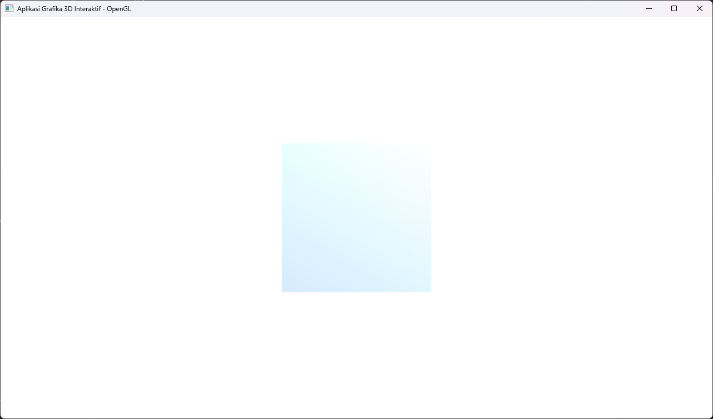

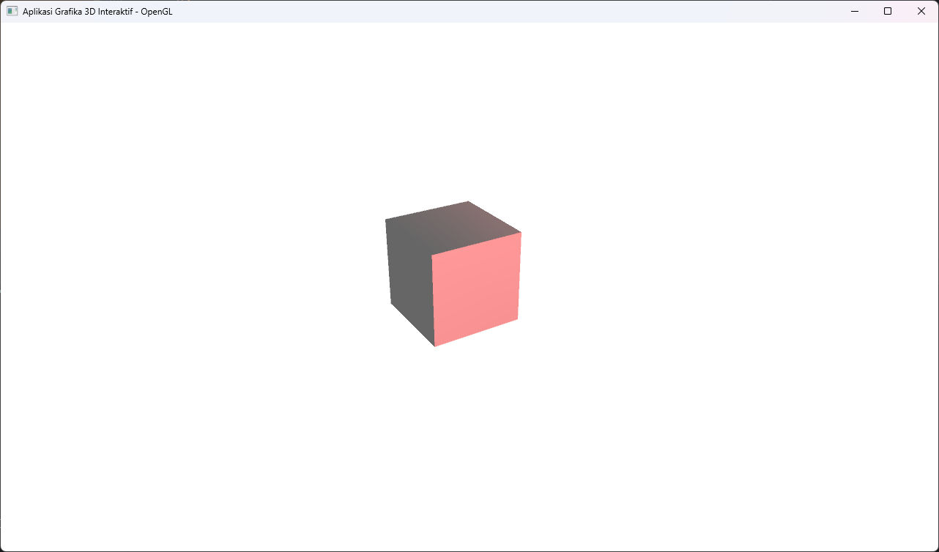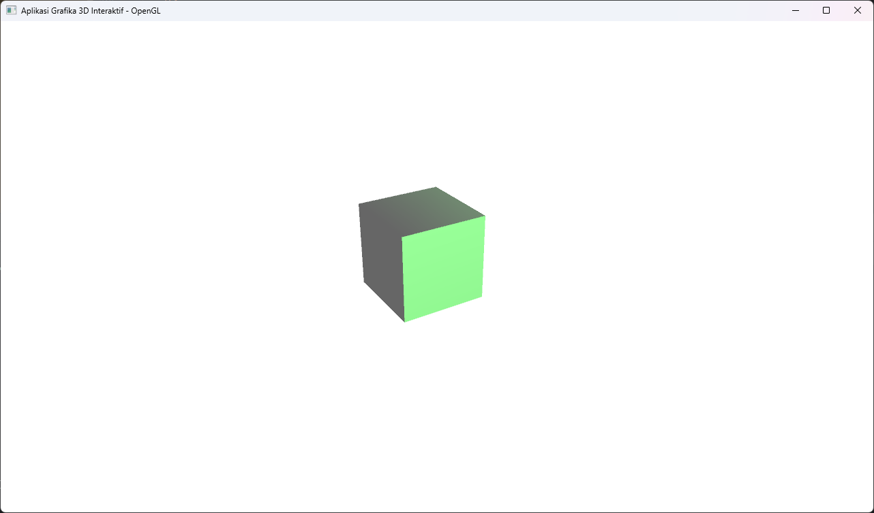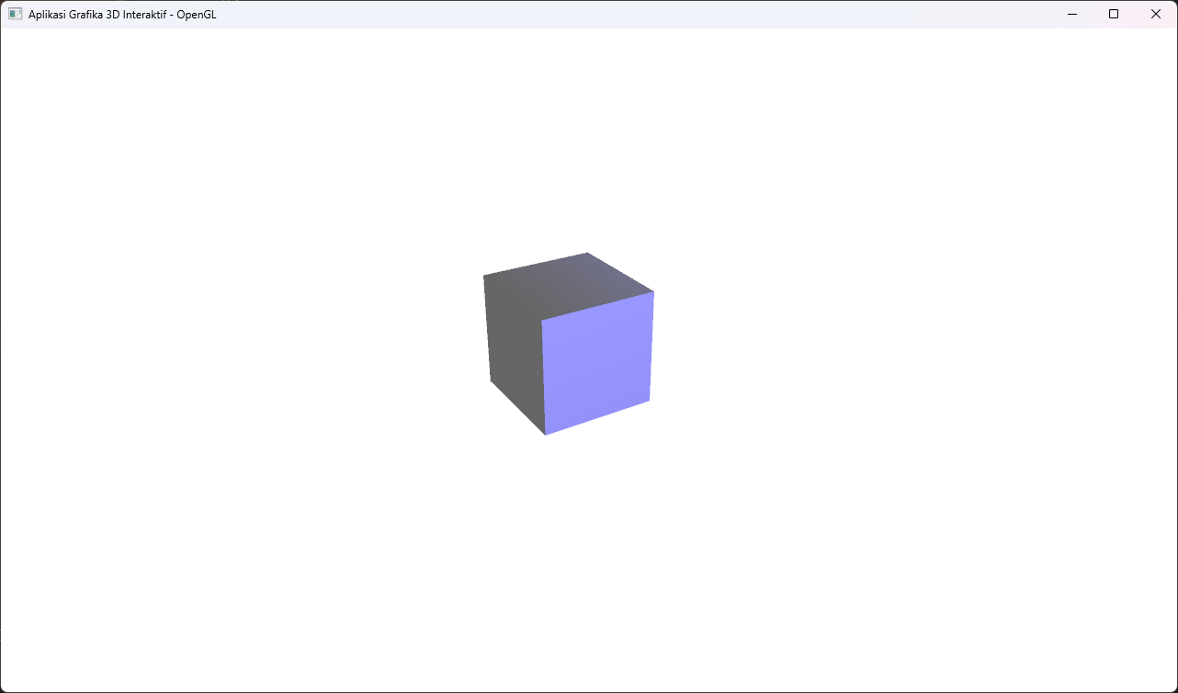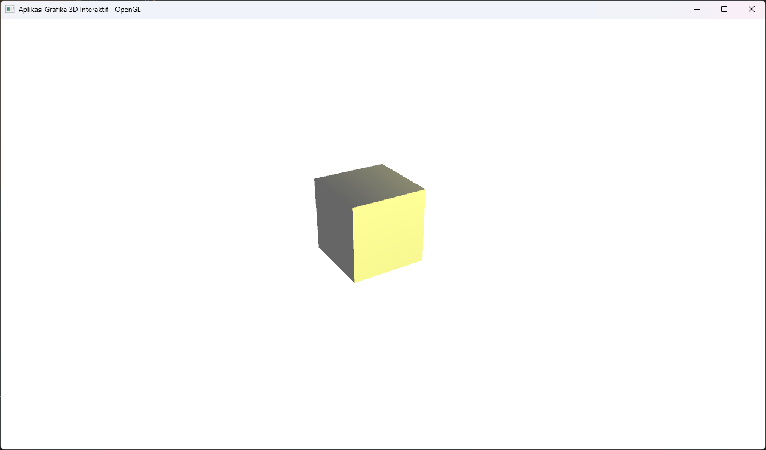

# Deskripsi Penjelasan Masing-Masing Output

## Output Modul A 2D

Output dari program Modul A menunjukkan bahwa seluruh fungsionalitas yang disyaratkan dalam soal telah berhasil diimplementasikan. Penjelasan untuk setiap output visual adalah sebagai berikut:

* Output Terminal

Saat program dijalankan, terminal akan menampilkan panduan penggunaan aplikasi secara lengkap. Ini mencakup informasi mengenai:

* + **Mode Menggambar**: Tombol untuk beralih mode menggambar Titik [P], Garis [L], Persegi [R], dan Elips [E].
  + **Seleksi & Transformasi**: Cara menyeleksi, menggeser, melakukan translasi (Panah), rotasi (Q/A), dan skala (W/S) pada objek.
  + **Manajemen Objek**: Shortcut untuk menyalin (Ctrl+C), menempel (Ctrl+V), dan menghapus (DELETE) objek.
  + **Atribut**: Pilihan untuk mengubah warna dan ketebalan garis.
  + **Windowing & Clipping**: Perintah untuk membuat [C], menonaktifkan [D], dan menggeser [G] window.
* Tampilan Awal Aplikasi

Gambar ini menunjukkan jendela aplikasi saat pertama kali dibuka. Terdapat sebuah kanvas putih kosong yang siap digunakan sebagai area untuk menggambar objek-objek 2D.

* Penggambaran dan Seleksi Objek Dasar

Serangkaian gambar output menunjukkan keberhasilan program dalam menggambar berbagai objek dasar sesuai spesifikasi soal, yaitu **Titik**, **Garis**, **Persegi**, dan **Elips**. Input koordinat untuk menggambar objek-objek ini dilakukan melalui klik mouse pada kanvas. Pada setiap gambar, terlihat satu objek berwarna oranye, yang menandakan bahwa objek tersebut sedang dalam mode terseleksi.

* Perubahan Atribut dan Manajemen Objek

Output visual menunjukkan beberapa objek dengan warna yang berbeda-beda (merah, hijau, biru) dalam satu kanvas. Hal ini membuktikan bahwa fungsi untuk mengubah warna objek telah berhasil diimplementasikan sesuai kebutuhan. Selain itu, adanya beberapa objek identik menunjukkan fungsionalitas seperti *copy-paste* juga berjalan.

* Transformasi Geometri

Gambar output menampilkan sebuah elips yang telah terseleksi (oranye) dan posisinya sedikit bergeser atau berotasi dari elips lain yang identik. Ini menunjukkan implementasi dari fitur transformasi geometri, di mana objek yang telah digambar dapat dikenai **translasi**, **rotasi**, atau **scaling**.

* Windowing dan Clipping

Gambar output ini secara efektif mendemonstrasikan fungsionalitas *windowing* dan *clipping*:

* + Sebuah *window* aktif telah berhasil ditentukan, ditandai dengan area persegi panjang bergaris putus-putus merah.
  + Objek yang sepenuhnya berada di dalam *window* (sebuah persegi) berubah warna menjadi hijau, sesuai dengan spesifikasi soal.
  + Objek yang posisinya sebagian di dalam dan sebagian di luar *window* (objek garis dan persegi besar) akan dikenai *clipping*. Hanya bagian dari objek yang berada di dalam *window* yang ditampilkan, sementara sisanya dihilangkan. Ini membuktikan implementasi algoritma *clipping* seperti Cohen-Sutherland telah berhasil.

## Output Modul B 3D

Output dari program Modul B menunjukkan keberhasilan implementasi aplikasi untuk visualisasi dan manipulasi objek 3D yang interaktif.

* **Output Terminal** Saat program dijalankan, terminal menampilkan panduan penggunaan aplikasi 3D. Panduan ini mencakup kontrol untuk:
  + **Manajemen File**: Impor [I] dan Ekspor [O] model dalam format .obj.
  + **Kontrol Objek**: Rotasi menggunakan mouse, Zoom dengan *scroll wheel*, dan Translasi dengan tombol W, A, S, D.
  + **Perubahan Warna**: Shortcut keyboard untuk mengubah warna objek menjadi Merah, Hijau, Biru, dan lainnya.
* **Visualisasi dan Shading Objek 3D** Output visual menampilkan sebuah objek kubus 3D yang dirender pada kanvas. Masing-masing sisi kubus memiliki tingkat kecerahan warna yang berbeda. Hal ini menunjukkan bahwa implementasi model pencahayaan sederhana, yang mencakup komponen *Ambient*, *Diffuse*, dan *Specular Light*, telah berhasil diterapkan. Efek *shading* ini memberikan kesan kedalaman dan volume pada objek.
* **Transformasi Objek 3D** Serangkaian gambar output menampilkan kubus dari berbagai sudut, ukuran, dan posisi. Ini membuktikan bahwa fitur transformasi 3D telah diimplementasikan dengan benar:
  + **Rotasi**: Objek dapat diputar secara bebas menggunakan klik dan seret mouse.
  + **Translasi**: Objek dapat digeser pada sumbu X dan Y menggunakan tombol W, A, S, D di keyboard.
  + **Skala (Zoom)**: Ukuran objek dapat diperbesar atau diperkecil menggunakan *scroll wheel* pada mouse.
* **Perubahan Warna Objek** Gambar-gambar output menunjukkan kubus yang sama ditampilkan dalam berbagai warna, seperti merah, hijau, biru, dan kuning. Fungsionalitas ini, yang diakses melalui *shortcut keyboard, berhasil mengubah warna dasar material objek sambil tetap mempertahankan kalkulasi shading dari sumber cahaya.*
* **Kamera dan Perspektif** Seluruh rendering objek 3D menggunakan proyeksi perspektif (gluPerspective) dan posisi kamera diatur menggunakan gluLookAt. Hal ini memberikan tampilan yang realistis, di mana bagian objek yang lebih jauh dari kamera akan tampak lebih kecil, sesuai dengan cara kerja pandangan mata manusia.

# Referensi/Sumber Pengerjaan Project

de Vries, J. (n.d.). Retrieved from LearnOpenGL: https://learnopengl.com/

*Line Clipping | Set 1 (Cohen–Sutherland Algorithm)*. (2024, March 12). Retrieved from GeeksforGeeks: https://www.geeksforgeeks.org/line-clipping-set-1-cohen-sutherland-algorithm/

*OpenGL Lighting*. (n.d.). Retrieved from Tutorialspoint: https://www.tutorialspoint.com/opengl/opengl_lighting.html

*PyOpenGL 3.1.7 documentation*. (n.d.). Retrieved from PyOpenGL: http://pyopengl.sourceforge.net/documentation/index.html

Wikipedia contributors. (2025, June 2). *Wavefront .obj file*. Retrieved from Wikipedia: https://en.wikipedia.org/wiki/Wavefront_.obj_file